TAG Programming:  The following are a small selection of some of the 2018-2018 enrichment events available to interested talented and gifted students:  - Mock Trial  - Music enrichment  - Art enrichment  - Robotics  - Stock Market  - Creative writing  - Mystery writing  TAG Practices  Students identified for talented and gifted begin services in grade three.  A universal screener administered in grade three is one of the data sets used among myriad of informational resources including teacher referral information, parent referral information, summative testing data, areas of artistic expression.  Students are served through the NMPS TAG program in grades 3-8 during a rotation cycle. In grades 9-12, students have opportunities for advancement through courses selected at the high school level. |  | Dr. de St. Croix’s 2018-2019 Schedule  Day 1 and 5:  Sarah Noble Intermediate  Day 2: Hill and Plain Elementary School in the morning, followed by  Northville Elementary School in the afternoon  Day 3: Planning across multiple locations  Days 4 and 6:  Schaghticoke Middle School
 | 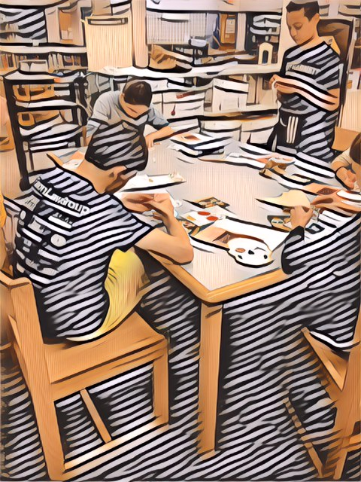
 |  |  |  | New Milford Public Schools Talented and Gifted 2018-2019

 |  | Program, Practices, and Policy  For our New Milford Public Schools students, our TAG program will plan interactive, engaging, enriching activities and programming to promote the diverse and distinct talents exhibits by our student population.  With student input, our program will provide appropriately challenging learning opportunities to allow student opportunities to interact with each other in order to develop connections and bonds.  We look forward to meeting and working in collaboration with parents and stakeholders to share relevant TAG  information, concise facts, informed data, and current policies.  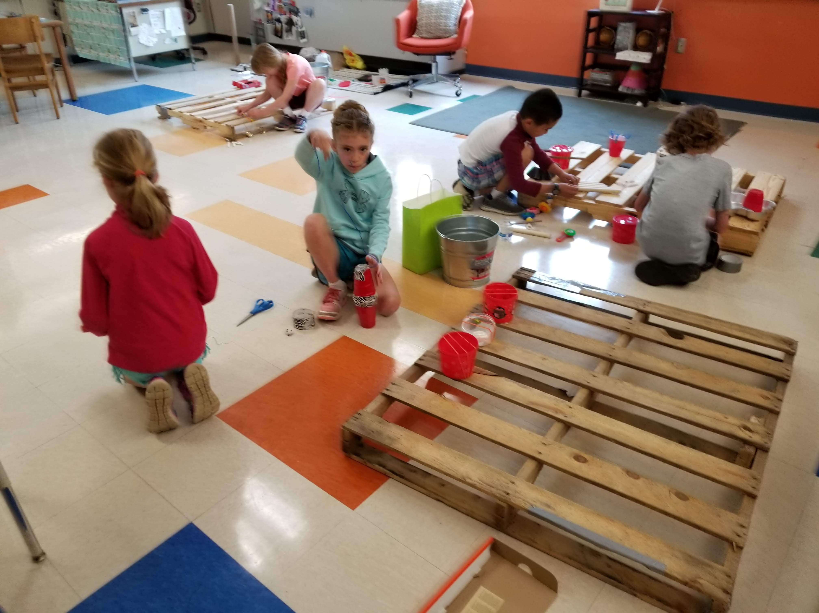 |  | With great excitement, TAG works to meet the unique learning needs of students within New Milford Public Schools
Role of Talented and Gifted Educator  - Nurture the social and emotional well being of talented and gifted students by recognizing their individual strengths and learning styles  - Identify and support TAG students of all backgrounds  - Design standards-based programs that connect and overlap wit hfine art and subject-based curriculum  - Empower families and stakeholders with necessary and timely resources regarding TAG  - Identify students with high potential. Then develop or modify enrichments and curriculum extensions in response to their needs |  |  |  | NMPS TAG: Talented and Gifted in New Milford, CT  TAG builds bridges between administrators,  classroom teachers,  data assessment advisors,  professional development  and curriculum coordinators,  language acquisition specialists,  and our special needs educators  to provide for continual opportunities  to embed awareness of and practices  for gifted and talented students’  school needs.  ﻿Contact Dr. Yvonne de St. Croix at destcroixy@newmilfordps.org  or via phone at (860) 354-2204  Visit our website at www.nmpstag.com

